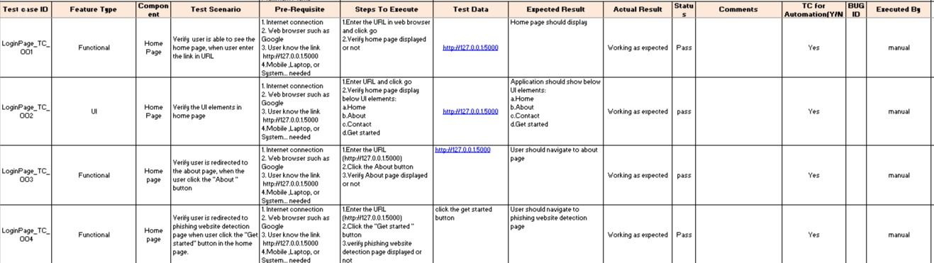

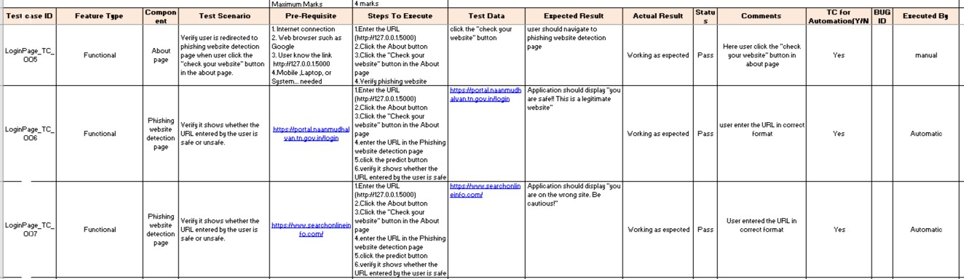

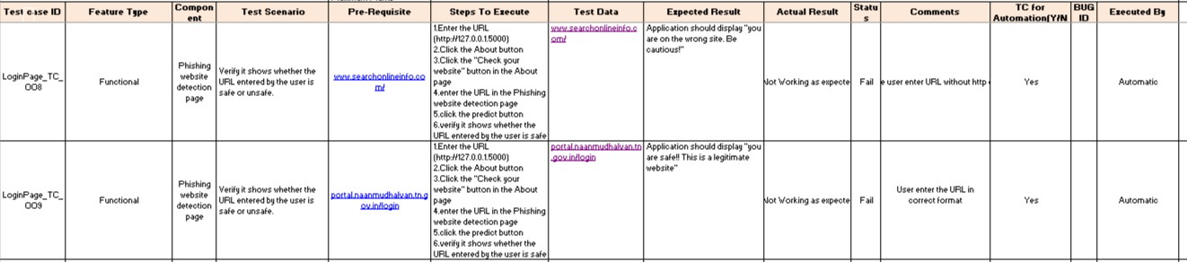

# USER ACCEPTANCE TESTING:

Here we briefly explained the test coverage and open issues of the Web Phishing Detection project at the time of the release to User Acceptance Testing (UAT).

# DEFECT ANALYSIS:

This report shows the number of resolved or closed bugs at each severity level, and how they were resolved

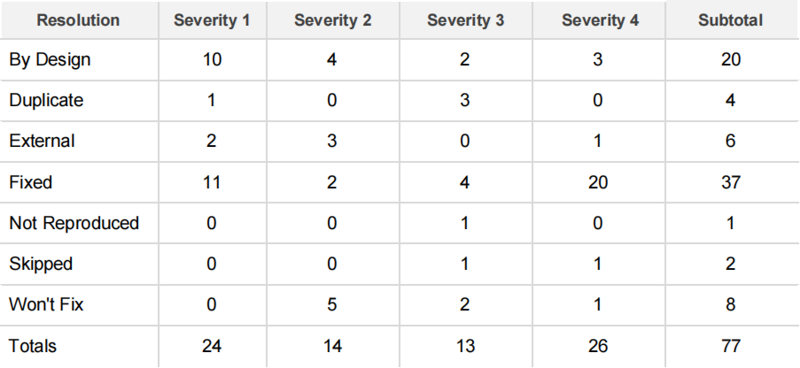

# TEST CASE ANALYSIS:

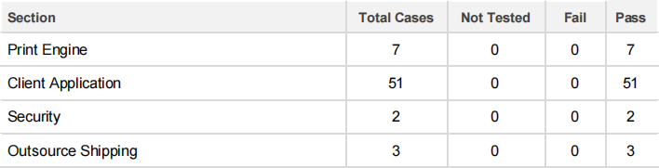This report shows the number of test cases that have passed, failed, and untested

